**PROJECT PART 1**

Medha Kant, 2017CS10350

Extending the previous part, support for caustics are added. Also, a distance parameter is added to photons inside bounding box, to account for the distance of the actual photon from the point of intersection. This time too the scene has 3 spheres, 2 of which are glass balls and the other is a diffuse reflective sphere. The rest of the scene is same as before. A separate map for caustic photons were added to ensure sharpness in the rendered image. Also, to make the image more realistic, a ray tracing + photon mapping model is used. Photon mapping is used to light up the scene and for caustics and ray tracing for refraction and reflection.

For the purpose of this assignment, I took help from a pdf - “A Practical Guide to Global Illumination using Photon Mapping, Siggraph 2001, Course 38” and from the book “Realistic image synthesis using photon mapping”.

Below is are some rendered images with different parameters-

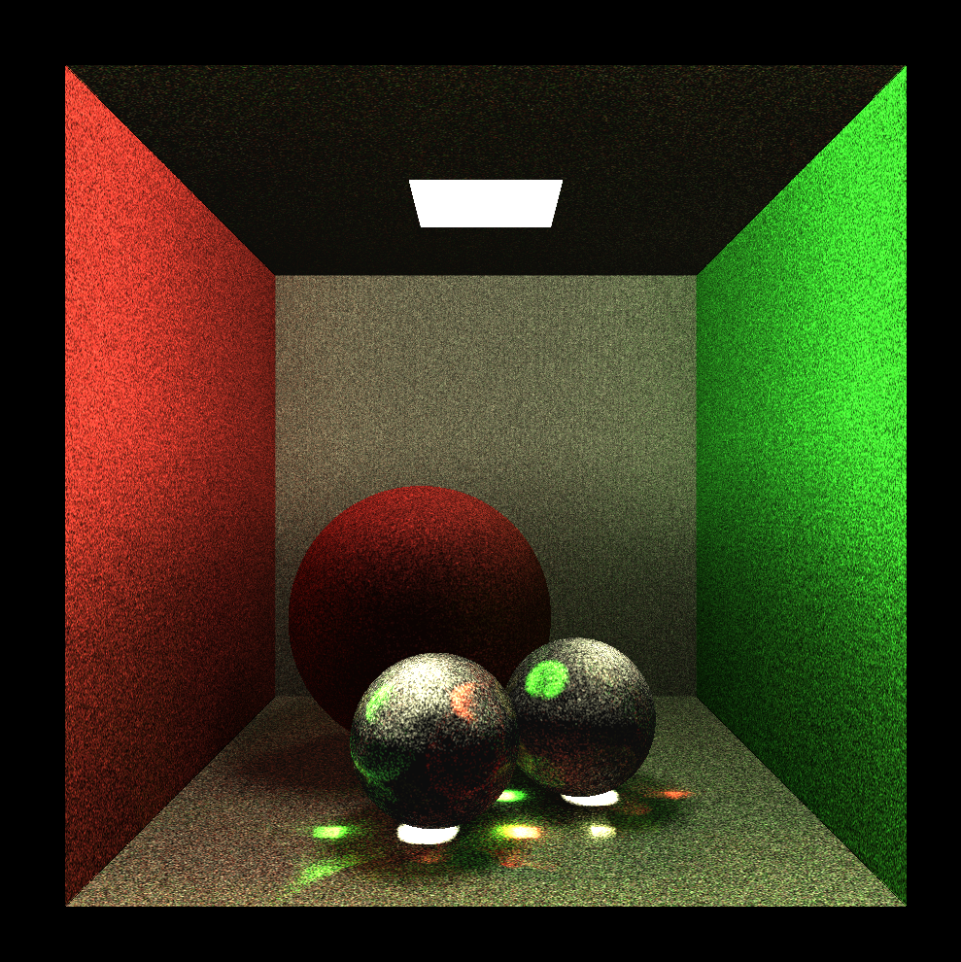

This image uses only photon mapping for illumination. We can see caustics are present, smooth shadows and color bleeding. But the glass spheres don’t look good particularly. This is because any photon coming from behind, goes out of the box and is not stored.

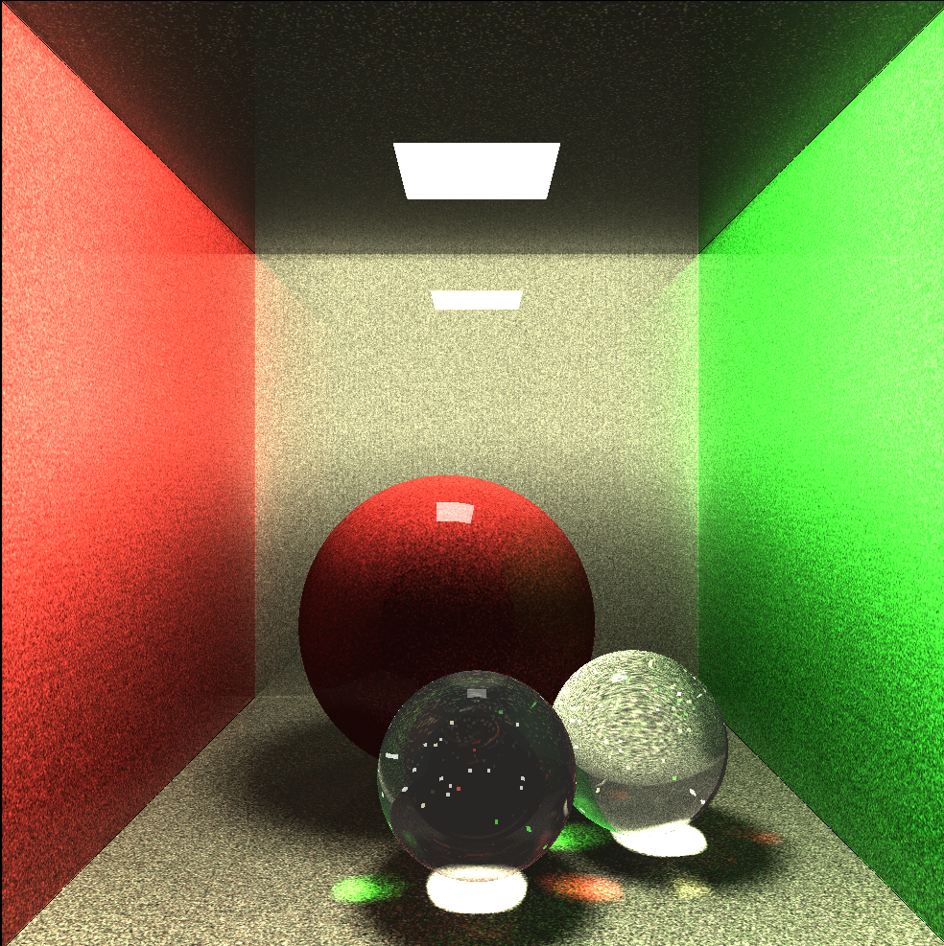

This image is rendered using photon mapping and ray tracing model. We see the background refracting through the glass sphere and all other things we previously had just with photon mapping model. Also, walls are slightly specular, therefore we see a reflection there too. This is much better than just the photon mapping model.

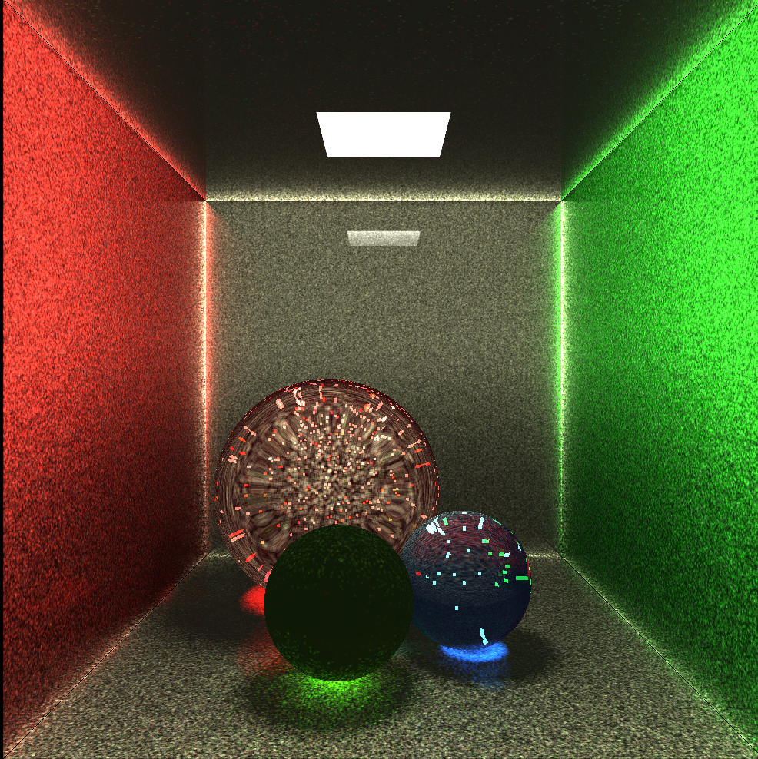

In this render, all the spheres are made of glass and they are colored. We see the same caustics pattern, but now they are colored as they should be.